Climate Change – The evidence and arguments for the causes and the consequences
I'm not a scientist, but I am naturally curious about how the world works. One of the most profound issues for the planet is climate change. The extent to which this is happening, and the causes and the consequences, is a matter of debate and a great deal of polarised opinion. Like the issues of immunisations and statins, there is a sizeable minority that choose not to believe the weight of scientific opinion. These views shouldn’t be dismissed out of hand. Science, and the policy change that results from it, is a progressive thing that benefits from counter-arguments. It wasn’t so long ago that the consensus view was that the Earth was flat, and at the centre of the universe.
In reviewing the issues around climate change for myself, I’ve tried to be open-minded and ready to question the quality and consistency of the evidence, to the extent I can, rather than take it at face value.
What I think I understand is as follows, although I remain fully open to challenge and further evidence.

Temperature Change Over Time
To 2025 there has been a ~1.3 degrees Celsius rise in the underlying global average surface temperature measured from a baseline between 1850 and1900, before industrialisation got going in much of the world.
The rate of increase is itself increasing, with 1-degree Celsius of this change happening in the last 40 years. This change in climate can be clearly seen in the graph below, underlying the year-to-year variation in weather.
Global mean temperature difference from 1850-1900 (ºC)
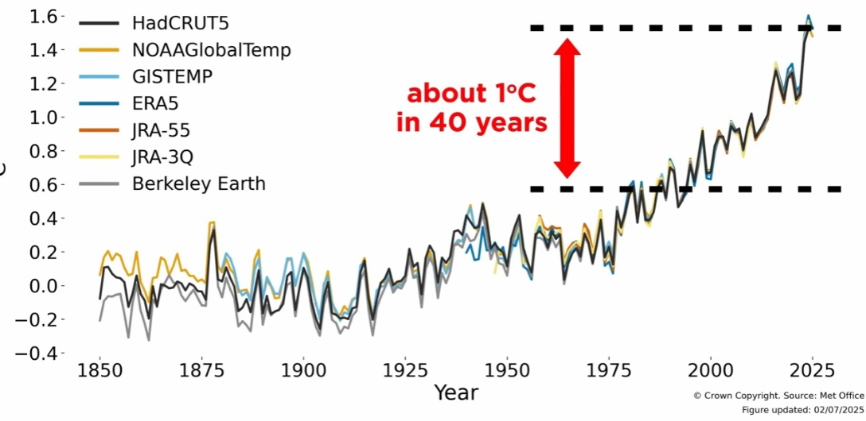
The last 3 years to 2025 have been the hottest globally in the modern temperature record.
Global Mean Average Surface Temperatures compared to the pre-industrial average
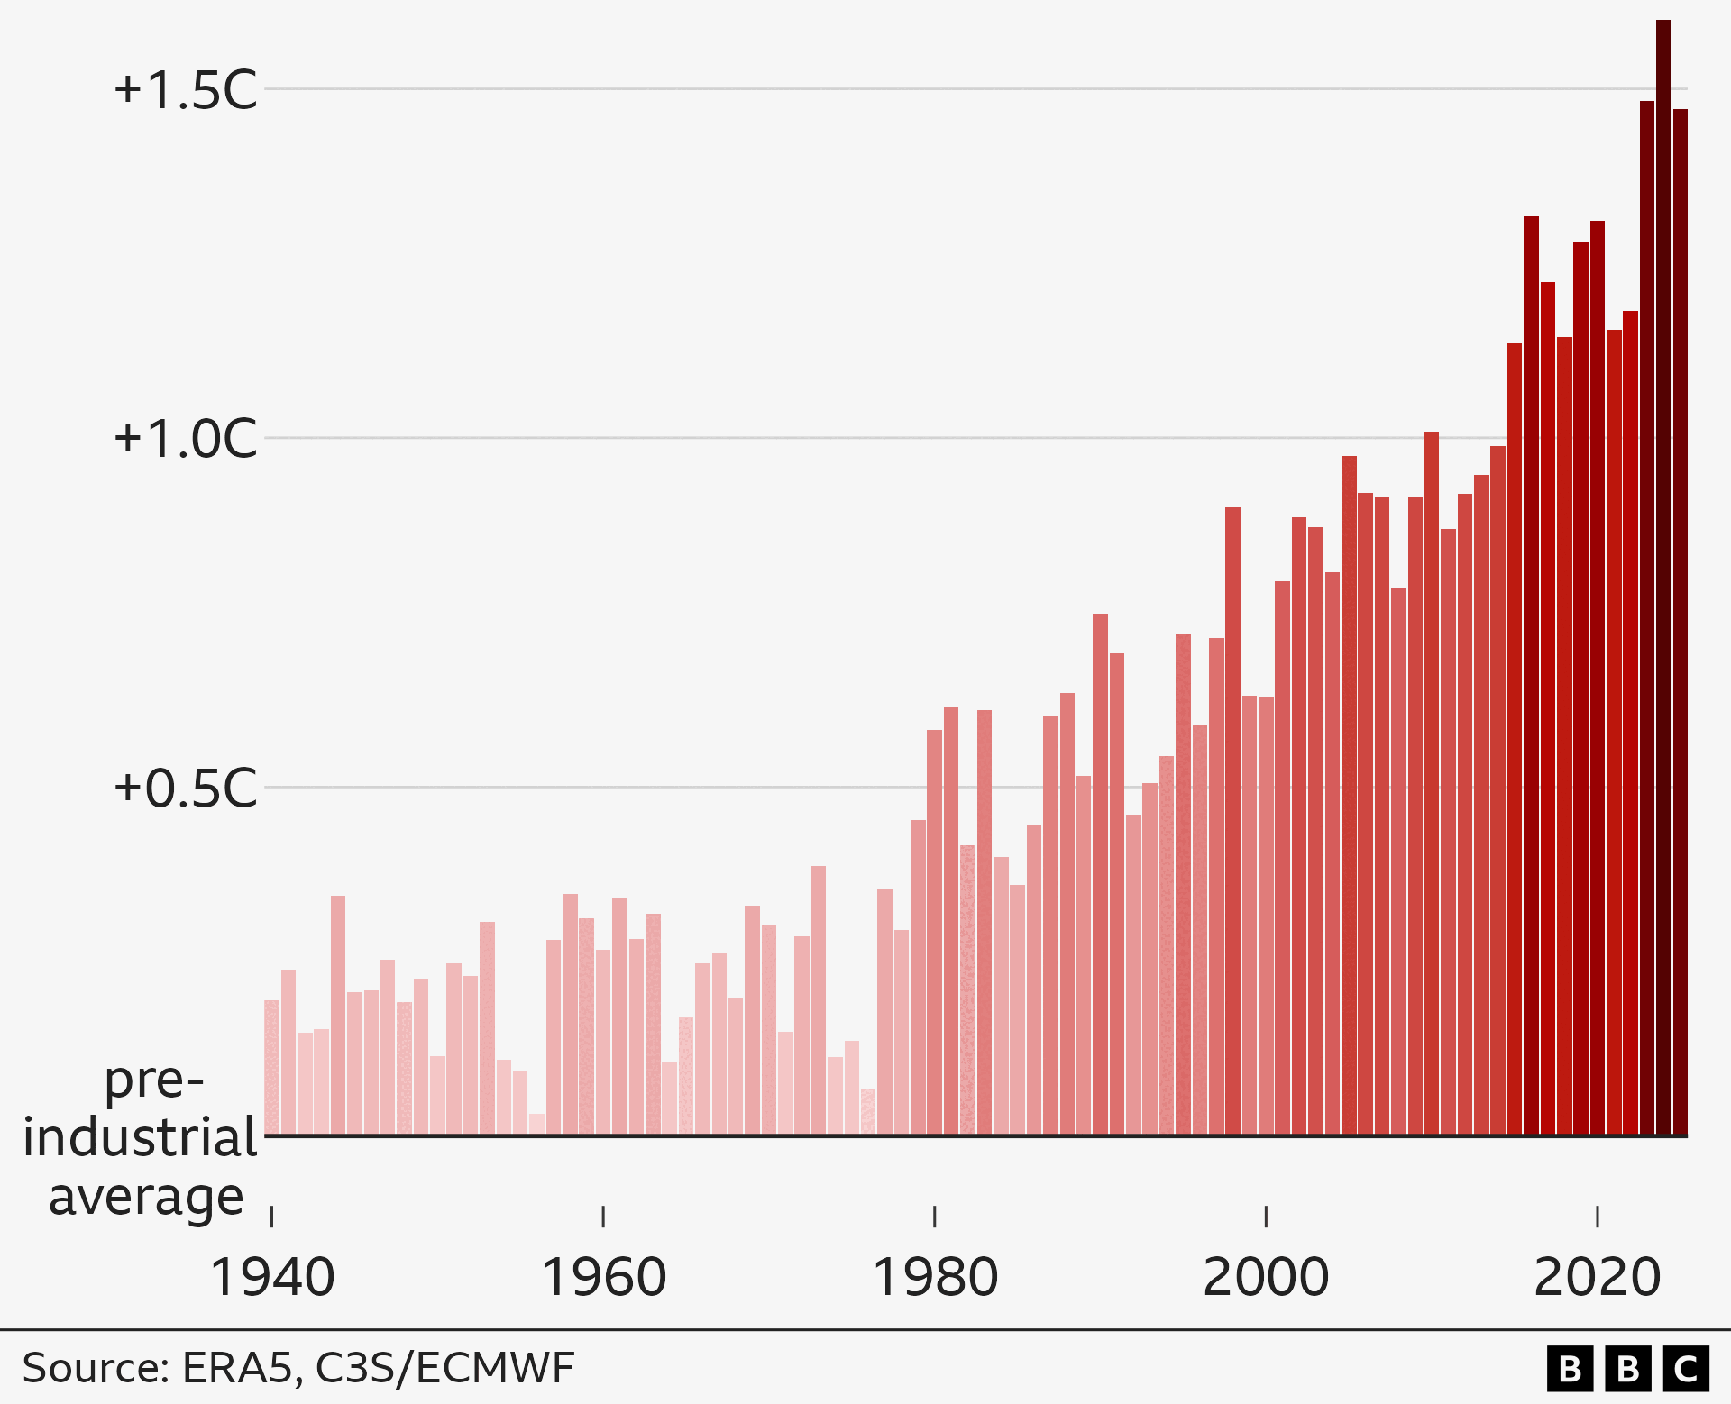
Prior to the advent of regular temperature measurement, which stretches back to 1659 for central England, and well before measurement by satellites, temperature can be estimated using various proxy measures including isotopic analysis. This measures the natural variation in the relative abundance of isotopes of various elements in rocks. There is a greater degree of uncertainty about the level and timing of temperatures, but this paleoclimatology construction represents the best current scientific understanding. This indicates that current global average surface temperatures are now higher now than in the past 125,000 years.
Climate warming sceptics refer to Roman and Medieval warm periods. These warm periods existed in Europe and the North Atlantic but were not globally synchronous events like modern warming. Similarly, the scientific consensus is that while parts of the world, especially the Arctic, were warmer during the Holocene Thermal Maximum around 6,500 years ago, current global temperatures have likely surpassed the Holocene peak when averaged globally and annually.
Constructed temperature records further back in time, over the last 800,000 years, indicate that the underlying global average temperature (the black line in the graph below) has varied in a relatively narrow range of +2.5 to -5 degrees Celsius compared to a baseline average between 1951 and 1980.
The peaks and troughs in temperature mirror the glacial and interglacial periods when polar ice advanced and retreated across the globe. During the glacial maximums ice sheets covered northern Europe, northern Asia and the north of North America.
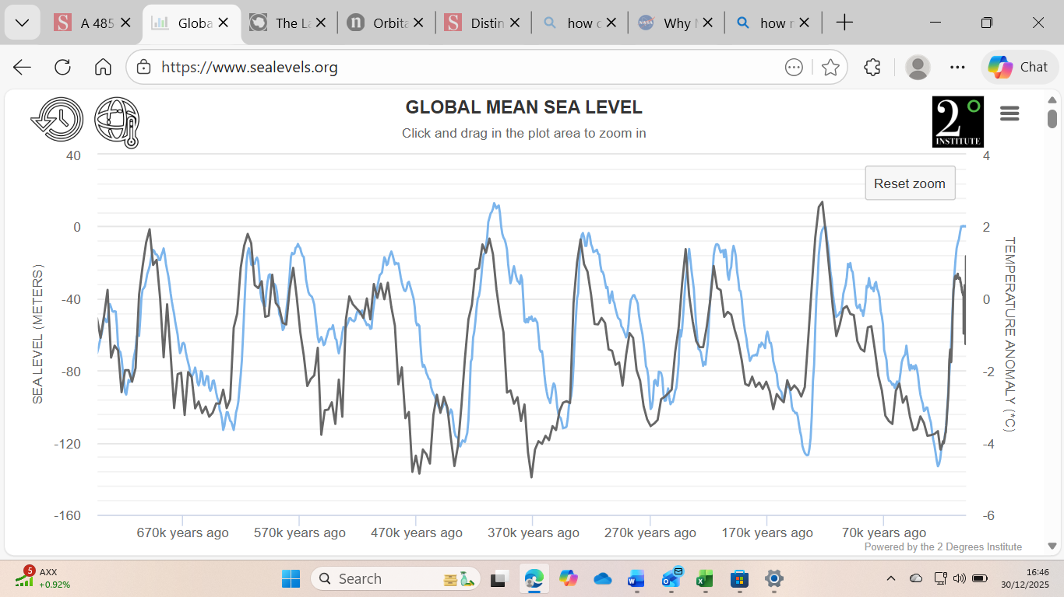
*Base period for temperature anomaly: 1951-1980
Across the whole period, sea levels (blue line in the graph) were as much as 130 metres below and 13 metres above current levels. Sea level peaks and troughs closely followed global temperature,
The principal reason for these swings in temperatures over tens-of-thousands of years in temperature and ice-coverage / sea-level are thought to be changes in the shape of Earth’s orbit around the sun and the angle the axis of the earth is tilted towards the sun. Named after the scientist that developed the concept, these ‘Milankovitch cycles’ affect the amount of energy from sunlight that the Earth absorbs from the Sun. This is not thought to be behind the changes in temperature in the past decades as Milankovitch cycles operate on very extended time scales, ranging from tens of thousands to hundreds of thousands of years.

Temperature Change and Greenhouse Gases
Greenhouse gases absorb particular wavelengths of infrared photons of light re-emitted from the earth. This ‘blanket’ of gases traps the energy that would otherwise go back into space. Observational data from satellites shows that warming is occurring in the Troposphere (lower atmosphere) and cooling in the Stratosphere (upper atmosphere). This is consistent with a ‘blanket’ effect from the trapping of greenhouse gases.
Water vapour in the atmosphere is one of these Greenhouse Gases. Water vapour plays a major part in keeping the earth warm and in the day-to-day variability in weather. However, this is a relatively stable effect over time as it is a short-lived, repeating cycle of water evaporating, condensing and precipitating that broadly averages out across the globe.
Other Greenhouse Gases include carbon dioxide, methane and nitrous oxide. These gases can remain in the atmosphere for years, in the case of carbon dioxide for more than a century. In 2025 the level of non-condensing and non-precipitating greenhouse gases around the earth is nearly twice as concentrated as pre-industrial levels; ~530ppm vs ~275ppm carbon dioxide equivalent. Of this, approximately 425ppm is carbon dioxide making this, by far, the most significant of these greenhouse gases.
In the last 150 years, during which time both carbon dioxide levels and temperature records have been measured, there has been an apparent correlation between the level of Carbon Dioxide in the atmosphere and global average temperature as shown in the graph below:
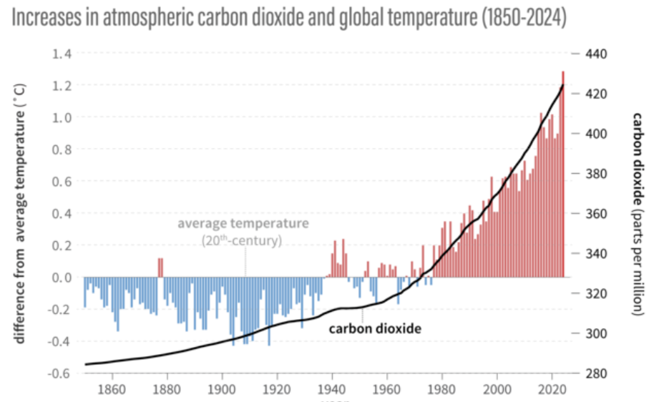
Source: NOAA Climate.gov adapted from original by Dr. Howard Diamond (NOAA ARL)
Carbon dioxide, and the wider composition of the atmosphere, can be measured accurately much further back in time from trapped air bubbles in ice cores that can be drilled to date back over a million years.
This data and collated temperature data from a range of proxy measures also shows a correlation between the level of carbon dioxide in the atmosphere, (blue line in the graph below), and global average surface temperature, (black line in the graph below), over the past million years.
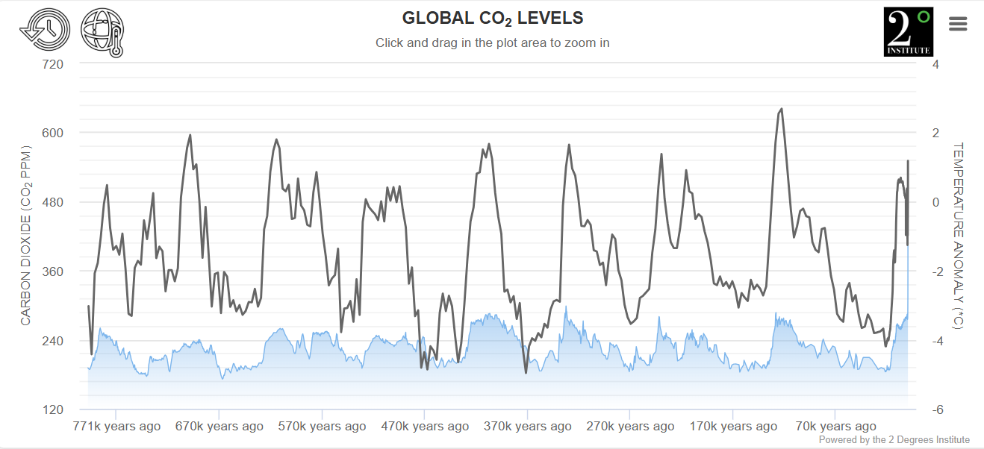
*Base period for temperature anomaly: 1951-1980

Carbon dioxide comes from human respiration, which emits around 2.5 billion tonnes per year, animal respiration, plant decomposition and other natural sources. The increase over the past 150 years in carbon dioxide remaining in the atmosphere to 425ppm on the very far right of the graph, has come primarily from the burning of fossil fuels. This 425ppm is equivalent to 3,340 gigatonnes of Carbon Dioxide.
Calculating the amount of carbon dioxide coming from fossil fuels is straightforward chemistry. The burning of a specific quantity of a grade of coal, oil and gas directly leads to the emission of a specific quantity of carbon dioxide.
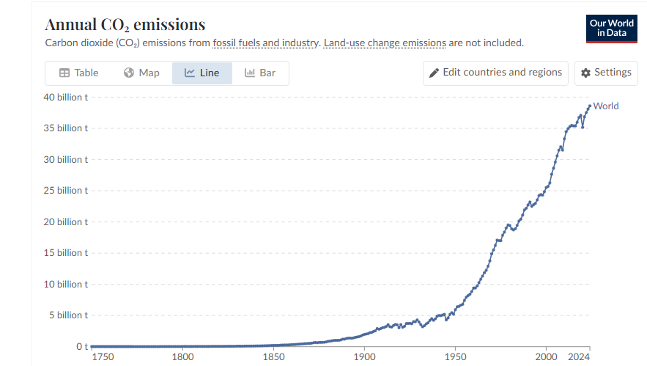
An estimated 2.5 trillion tonnes of carbon dioxide have been emitted by burning fossil fuels since the beginning of the industrial revolution. Current emissions are around 40 billion tonnes per year. It is broadly estimated that 10 billion tonnes is absorbed by the oceans. A further 10 billion tonnes is absorbed by the land. This includes photosynthesis, creating organic matter which is absorbed into soil, wetlands and lake sediments. The remaining carbon dioxide, around 20 billion tonnes stays in the atmosphere. This equivalent to an additional 2ppm of carbon dioxide each year.
Land, ocean and atmospheric cycles are complex. They interact with each other and with a range of natural phenomena such as ocean currents, El Nino / El Nina cycles, volcanos and solar irradiation as well as human activity such as burning fossil fuels, aerosol emissions, cement production, deforestation and agriculture.
Attributing the degree of change in temperature over time to any single variable is not straightforward and is subject to uncertainty. The correlation between estimated temperature and carbon-dioxide levels over hundreds of thousands of years, and the sharp rise in both over recent decades together with scientific explanation for a causal effect, rather than just correlation, makes for a compelling argument that the rapid increase in carbon dioxide in the atmosphere over the past few decades has been the primary driver of the global warming we have seen.
The impact of other man-made effects and the weight of natural influences such as tectonic plate movements is less clear. Human emissions of aerosols, particularly Sulphur dioxide from burning coal and fuel-oil, may be partially masking global warming. These aerosols reflect sunlight and increase cloud formation, both of which have cooling effects. The impact of such particles in the atmosphere has been directly observed with massive eruptions such as Tambora (1815), Krakatoa (1883) and Pinatubo (1991) sending enough ash and particles into the stratosphere to affect global temperatures for many months before they were dissipated by the wind and washed out by rain. The cooling effect of aerosols, which may be as much as 0.5 degrees Celsius, may now be reducing as, at least in the northern hemisphere, on-going sulphur emissions from coal-fired power stations and shipping have reduced. The possibility of using geo-engineering to artificially increase particulates in the atmosphere to block sunlight has been suggested as a means of temporarily cooling the earth. This could have many unintended consequences and widespread use could only be as a last resort.
The following graph seeks to estimate the impact of different influences on global temperatures over time. The impact of aerosols is shown as partially offsetting the effect of greenhouse gases to drive the ‘net forcing’ we have observed in recent decades.
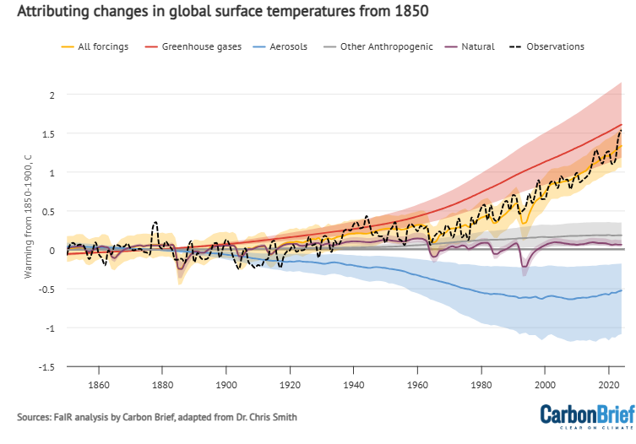
The relationship between the levels of carbon dioxide in the atmosphere and temperature is not thought to be linear as the ability of carbon dioxide to absorb and re-emit infrared irradiation changes with increasing concentrations of carbon-dioxide.
In 2025 an increase of 1.5 degrees Celsius in the underlying global average surface temperature was associated with approximately 425ppm of carbon dioxide in the atmosphere. 2 degrees of warming is associated with 500ppm and 3 degrees of warming with approximately 680 ppm.

Climate Change Sceptic Perspective
Climate Change sceptics maintain that increasing Greenhouse Gases should be seen as an overall positive thing. It is correct to say that if there was no Carbon Dioxide in the atmosphere the Earth would be a largely frozen, barren planet, around 15 degrees Celsius colder on average than it is today. If we were globally heading for a new period of glaciation, increasing greenhouse gases could help offset this, however, these changes typically occur over thousands of years, not decades.
More carbon dioxide in the atmosphere can also stimulate photosynthesis and biomass density. This is broadly a positive thing for agriculture and forestry, although studies show mixed effects. Additional photosynthesis also depends on a sufficiency of water, nitrogen, and other soil nutrients which may not be present.
Climate change sceptics question the relationship between carbon dioxide in the atmosphere and temperature. One argument is that levels of carbon dioxide and temperature have been quite different in deep-time. Within the Cenozoic period, covering the last 66 million years, concentrations of carbon dioxide, estimated through isotope ratios, were as high as 1,600 ppm. They dropped as low as 180 ppm during the Quaternary glaciation of the last two million years when humans have existed. Temperatures over this time-span, again inferred through isotopic analysis, varied between 3 degrees Celsius below and 12 degrees Celsius above pre-industrial levels.
Relationship between atmospheric Carbon Dioxide and Global Mean Surface Temperature over the past 66 million years
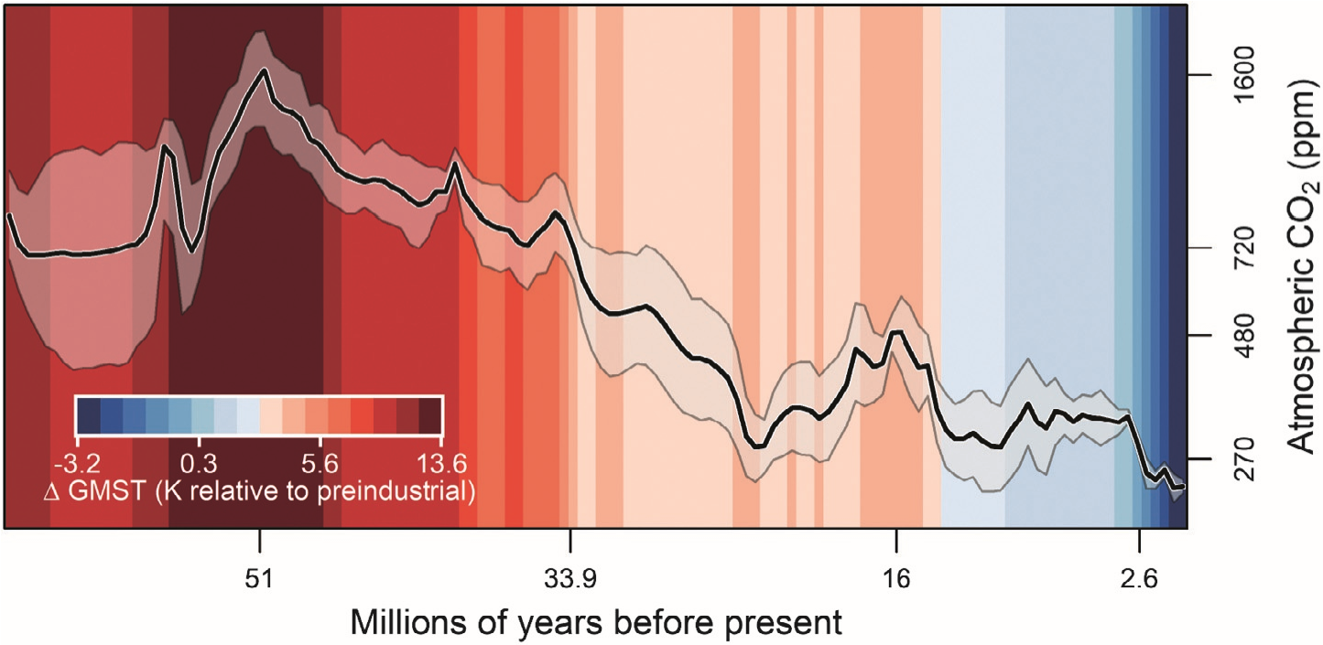
PETM
EECO
MECO
EOT
MCO
NHG
Source: Phanerozoic atmospheric CO₂ reconstructed with proxies and models: Current understanding and future directions. Steinthorsdottir et al 2025 (note a change of 1 Kelvin is equal to a change of 1 degree Celsius)
Simple statistical comparison of raw proxy data of temperature and carbon dioxide stretching back into deep time shows limited correlation. This was reported in some scientific papers and taken to indicate that carbon dioxide was not a prime driver of global warming, This approach has been widely criticised as it does not take account of major environmental changes over this time-span of hundreds of millions of years including; the evolution of life on earth, continental drift, solar luminosity changes, mountain-building and weathering, ocean circulation shifts and volcanism.
While not necessarily correlated in terms of level over time, it can be seen in the graph above that carbon dioxide and temperature have tended to move together throughout the Cenozoic Era.
The rise in both carbon dioxide and temperature over the past 150 years is not visible in a graph spanning 66 million years. It is noteworthy that current carbon dioxide levels of 425ppm have not been seen for some 14 million years.
A global average surface temperature increase of one to two degrees is regarded by some climate sceptics as inconsequential. It should, however, be borne in mind that the entire range of underlying temperature change in the last million years is only around plus 3 and minus 5 degrees compared to the 1951 to 1980 average. In this context a change of 1 degree in just 40 years is significant. As a global average, this masks significant regional variation. The underlying average surface temperature in the Arctic has risen by around 3 degrees and temperatures in the Nodic Region and Siberia by around 2 degrees. Eastern Antarctic and the Southern Ocean have remained stable or cooled slightly.
Some sceptics maintain that solar activity such as sunspots has much more impact than carbon dioxide. The sun is indeed the source of the vast amounts of heat reaching the earth. Over hundreds of millions of years radiated heat from the sun has changed, but these underlying changes are gradual. A weak correlated pattern was observed between 1900 and the 1970s, but since then data diverges.
There are some doubts about historic temperature readings because of the ‘urban heat island’ effect with weather stations increasingly surrounded by urban and sub-urban development which would tend to increase temperature readings. The extent of any bias in temperature data is hard to disprove, but I understand meteorologists continue to work to remove the possibility of such an effect and that the records of rural as well as urban weather stations show a very similar upward trend since industrialisation. A region where there has been the greatest rise in measured warming since the 1990s, and where lie the greatest concern about the consequences – the Arctic – has had none of this Urban Heat Island effect.
Finally, sceptics argue that all the conferences, media and investment in clean energy have done nothing to alter the growth of carbon dioxide in the atmosphere. That is true, however, global efforts have reduced what would otherwise have been a higher rate of growth, and therefore temperature, as the developing world industrialised.

Key factors driving future levels of Carbon Dioxide and Temperature
In 2024 40 billion tonnes of carbon dioxide was emitted into the atmosphere from the following sources:
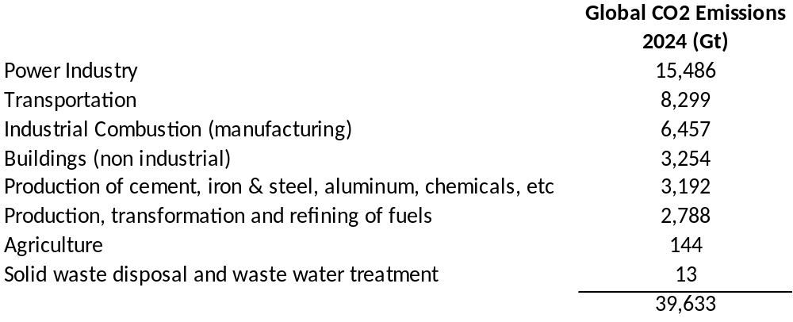
Source: EDGAR (Emissions Database for Global Atmospheric Research) Community GHG Database

The future path of these emissions is uncertain, but some of the key influences and uncertainties are as follows:
Consumption
With 8 billion people on earth wanting fresh water, electric light, to eat more meat, to have TVs, refrigeration, air-conditioning, cars and AI the underlying demand for energy will grow remorselessly. Developed countries grew their economies on the back of burning fossil fuels, morally it is hard to deny the right of less developed counties to do the same.
Burning of Coal
Global coal consumption is currently 9 billion tonnes per year. Burning this amount of coal emits approximately 13.3 billion tonnes of carbon dioxide, 35% of total annual carbon dioxide emissions from fossil fuels. Burning coal emits around twice as much carbon dioxide per unit of electricity generated as burning gas does.
Global coal use has nearly doubled over the past 20 years as a lot of new coal-fired power plants have been built, particularly in China and India. Expected retirements of old coal plant are not expected to exceed newly commissioned coal plant until around 2030. We may now have reached ‘peak coal’ with existing coal plant being progressively utilised less leading to earlier falls in emissions.
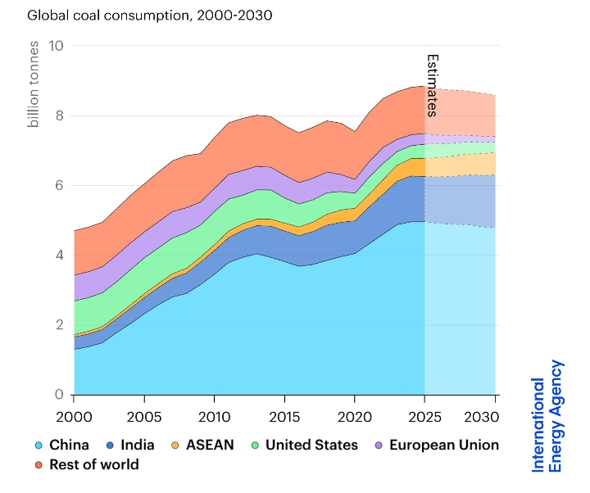
Factors that may influence a faster decommissioning of fossil fuel plant are the continued growth of renewable power and battery technology. The financial cost of solar power in the ‘sunbelt’ countries is competitive with coal and gas, however, as a means of coping with variable levels of generation, to provide grid system stability and to maintain the security of their own energy supplies, countries may elect to maintain a proportion of traditional fossil fuel generation.
Changes in Land and Ocean Carbon Cycles
Land and ocean carbon cycles are complex and are not fully understood by science, although this is progressively developing. There is no guarantee that the land and ocean absorption of carbon dioxide, estimated at 50% of emissions to the atmosphere, will continue at its current rate. The cycle by which oceans trap carbon through vertical currents and via sea life transporting carbon to the ocean floor where it is sequestered may change as oceans warm. On land, the carbon dioxide sink from additional photosynthesis and the resulting biomass may weaken, or even reverse, as climate change causes changes in precipitation patterns, droughts, desertification, fires and heat stress.
Growth of Renewable Power
Hydropower has been used for thousands of years so the most economic sites have been used. Further, engineering heavy, sites are being developed although these can require damming of rivers with significant consequences for local communities.
The cost of building solar power has progressively reduced, led by China, to the extent that it is now quicker and more economic to install and operate in many parts of the world than it is to commission new fossil fuel plants.
In the right locations and conditions wind power plays an important role. The costs of installing and operating offshore wind seem to be no longer falling meaning net wind capacity may not increase very significantly.
Rapid advances in battery technology for short and longer-term storage alongside other means of regulation such as pumped storage and quick response, low utilisation, gas plant means the variability of renewable power and the challenge of maintaining a stable power grid are becoming less of an issue.
Electrification
Renewable power can now, in many parts of the world, directly replace fossil fuel power generation. This still leaves over 60% of fossil fuel use to be replaced. Significant inroads are now being made by electric vehicles, electric heat pumps and converting key industrial processes from fossil fuels to electricity. There is clear potential to replace most fossil fuel use. With household and national budgets facing many pressures the speed of the transition is likely to be driven by relative cost efficiency. Some sector such as aviation and marine transport remain challenging, but technology is continuing to advance.
Innovation
There is a huge amount of innovation happening worldwide in the quest to replace fossil fuels and reduce energy usage. These range from more sector specific applications such as recycling heat from data centres to the, so far elusive, promise of cheap nuclear power to, potentially, completely game-changing developments such as nuclear fusion power with the prospect of limitless, clean, energy.

Global Warming Scenarios
In a scenario that assumes the rate of emissions remains at current levels, and absorption by land and ocean cycles remains at current proportions, then an additional 2ppm/year of carbon dioxide will remain in the atmosphere. This implies that 2 degrees of warming versus pre-industrial levels could be reached by the 2060s consistent with circa 500ppm carbon-dioxide. This is not out-of-line with the envelope of scenarios summarised by the IPCC in their Sixth Assessment.
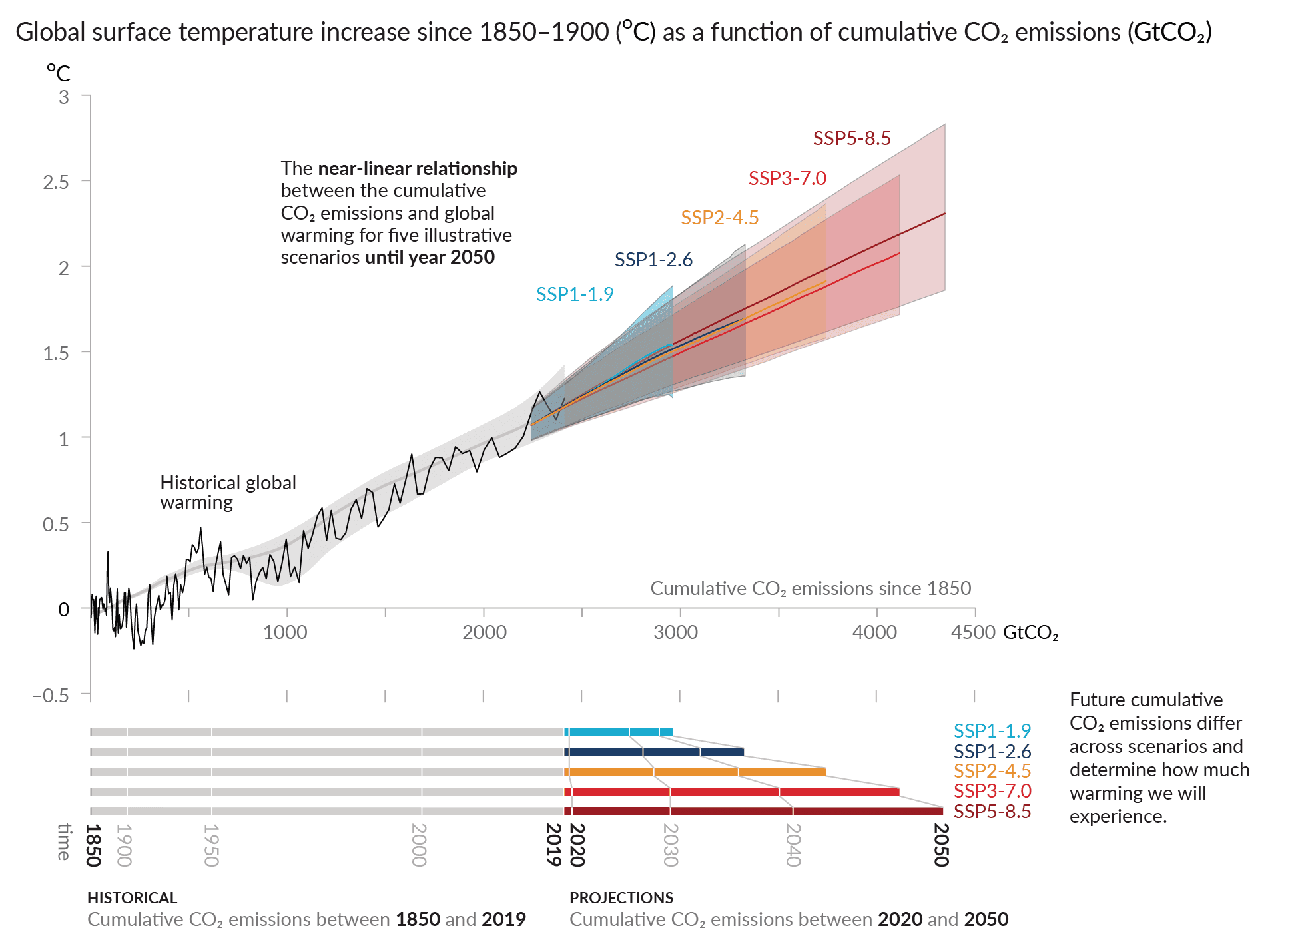
Source: IPCC Assessment Report 6 Working Group I, Chapter 4, Figure 4.3
If the current momentum behind renewable power and electrification stalls, there is the prospect of 3 degrees of warming by around 2150.
While these timescales can only be best estimates given the uncertainties around how the factors driving climate change will evolve, they are nevertheless indicative of the relatively short timescales involved. To put it in more human terms, there is a risk that the grandchildren of children today may live to see 3 degrees of underlying warming, consistent with circa 680ppm carbon-dioxide, and its consequential effects.
Conversely, again assuming other things remaining equal, if there is a sustained progressive next reduction in carbon dioxide emissions from fossil fuel use of 3% per year after 2030 in power, transportation and building, and 2% in other sectors, then fossil fuel emissions of around 10-15% of current levels could be achieved in each sector within 100 years. This could mean warming is contained at around 2 degrees.

Consequences of Global Warming
More extreme weather events such as droughts, flooding, hurricanes and forest fires. The greater media focus on extreme weather across the globe, and the increase in scientific research and reporting of climate change, may have artificially heightened our individual perception of extreme weather. However, in the same way that the occurrence of extreme weather should not necessarily be attributed to climate change, the relative absence of more extreme weather in individual countries or regions should not be used to discount the impact of global warming as patterns of change vary across the globe.
The science of the attribution of climate change to the impact of global warming continues to advance worldwide. This gains progressively more data each year, but is not yet a very long-term data series, particularly with much more limited historic data recording in the global south. However, in Assessment Report 6 the IPCC concluded, with high confidence, that human influence has increased the frequency and intensity of some types of extreme weather.
Droughts in recent years have, in many cases, been attributed to natural cycles of ocean currents such as El Nino, but these have been exacerbated by climate change. Major droughts have occurred in Australia (2001-2009, 2025), Western United States (2000-ongoing), South America (2023-2024), the Horn of Africa (2020-2023), Southern Africa (2023-2024) and the Middle East (2023-ongoing). Droughts and heat stress have a significant effect on agriculture, and on populations where clean water or water desalination for human consumption is not sufficient or affordable. Big cities cannot survive without water, witness the difficulties in Tehran.
Flooding, often caused by increasingly frequent heavy rainfall events in some regions, can equally be very destructive in damage and human lives. Major flooding occurred in China (2010), Thailand (2011), Pakistan (2022), South Western United States (2022), Western Europe (2021) and Libya (2023).
Despite the hundreds of deaths and billions of pounds of cost of damage the world has always experienced extreme weather and has developed irrigation, desalination, forestry management and flood defences to help mitigate the effects. Increased global resources and mitigation measures have meant the impact in terms of deaths has been declining. It could be argued that the magnitude of the increase in extreme weather experienced so far is something that the world can cope with.
Melting ice and rising sea levels – Satellites data, available since 1993 has been able to accurately measure sea level rise. This varies year to year, but the overall trend has been steadily upwards.

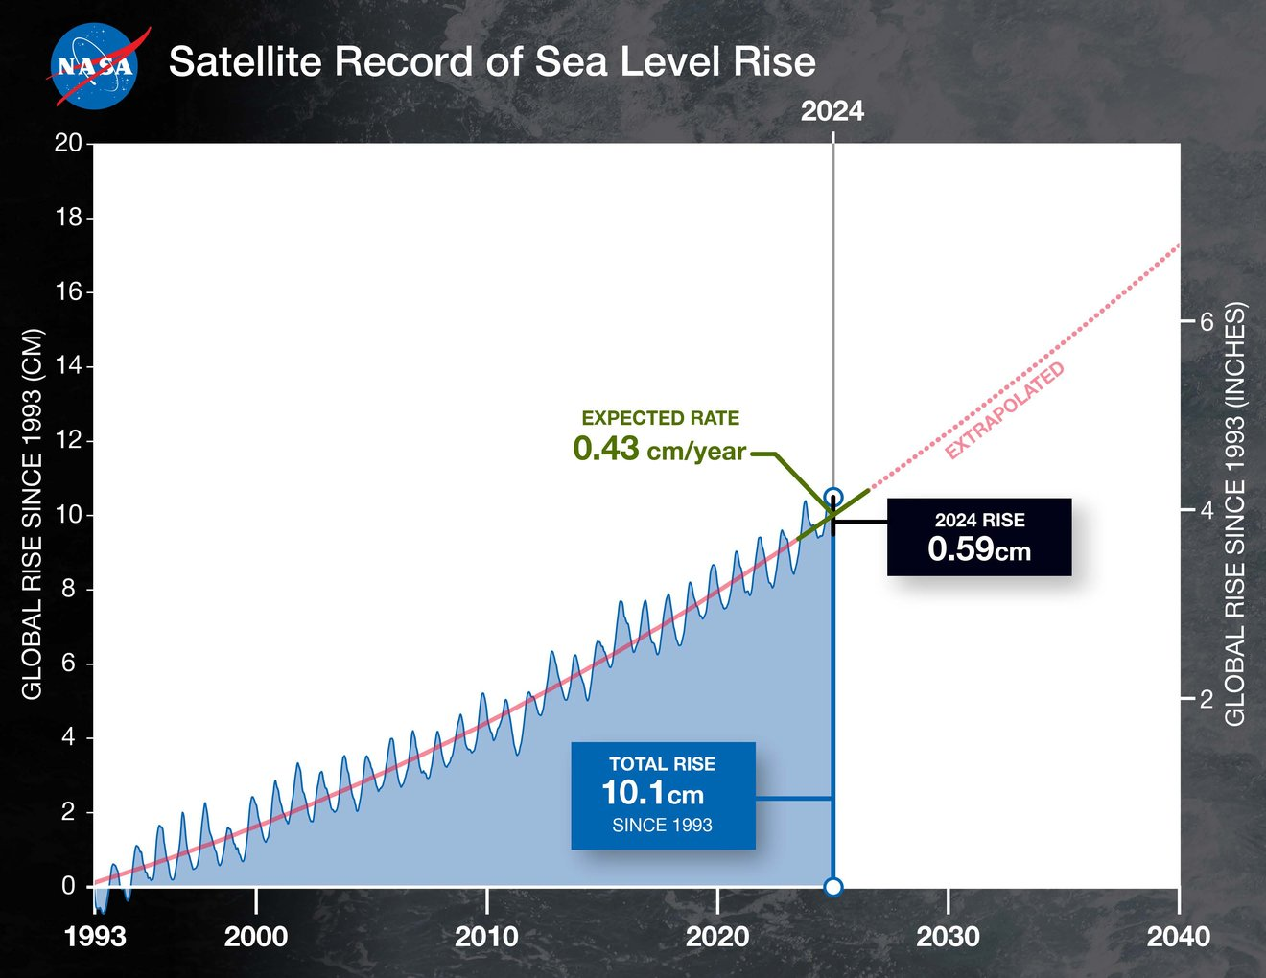

Prior to the advent of satellite measurements data on sea level rise was much less widespread and reliable. Reconstructions of this more fragmented data from the previous 200 years indicate that we are experiencing a somewhat accelerating rate of sea level rise from less than 1mm per year in the 1800s to the current rate of 3.5mm per year.
The components of current annual sea level rise break down as follows:
Component | Contribution (mm/yr) | Notes
Thermal expansion | 1.2–1.6 | Largest single term, but variable
Glacier melt | 0.7–1.0 | Strong, accelerating
Greenland melt | 0.7–0.8 | Accelerating, not offset by periods of increased snowfall increasing ice sheet mass
Antarctica melt | 0.3–0.4 | Highly variable, accelerating trend not offset by periods of increased snowfall increasing ice sheet mass
Land water storage | 0.2–0.4 | Very noisy as precipitation patterns change

A few millimetres a year may not seem significant, but it is relentlessly cumulative. On current trends, by 2100 sea level can expected to rise by at least a further 30cm.
There is significant uncertainty about the future speed of melting. It is plausible, even excluding low probability / high impact events such as ice sheet collapse, that sea levels could rise by a metre or more over the next century. Warmer seas melt more sea ice and reduce the albedo effect of ice reflecting sunlight. In turn this reinforces warming. 1 to 2 metres of sea level rise will bring regular coastal flooding and a significantly greater flooding risk to several major cities including Jakarta, Bangkok and New Orleans. Low lying islands will eventually become uninhabitable and saltwater ingress will severely damage agriculture and drinking water in vulnerable river deltas such as the Nile and Ganges which are home to tens of millions of people. Loss of mountain glaciers, which is already very evident, will likely significantly affect agriculture and food production that depends on meltwater.
Again, mitigating measures can reduce impact. A few cities now, including Amsterdam and New Orleans are below sea level. Over time, the consequences of sea level rise are still likely to be severe with more extreme weather events multiplying the impact of higher sea levels.

Reduced biodiversity on the land and sea – Biodiversity is already in crisis with hundreds of thousands of species at risk of extinction or in massive decline. The huge fall in insect abundance for example has important consequential effects because of their position in the food web.

The causes of bio-diversity decline are complex and inter-related including changing land use, use of pesticides and intensive farming and fishing practices. The extent to which climate change is an influencing factor is uncertain. While there may be some locally beneficial effects, at minimum, climate change is likely to accelerate the global biodiversity decline with habitat loss and degradation being more likely to occur due to changing weather patterns, more frequent and intense forest fires, more extreme heat and sustained drought conditions.

The current and future impact on oceans is particularly unclear with ocean acidification, marine heatwaves and sea level rise potentially seriously affecting sea life including reduction in fisheries, extinction of marine species and bleaching of coral reefs.
Many of these effects of global warming have already been observed. These will get more extreme as we move past 2 degrees warming in the next few decades. With 8 billion people, growing at a rate of 70 million per year, spread across the planet, the impact of climate change will be felt by millions of people and much of the eco-systems we live in.
The timeline for projections of climate change and its impacts typically reference the end of the century - 2100. This is less than a lifetime away. What could happen in three or four hundred years should also, be very much our concern. The long-term consequences from the cumulative effects of climate change are something that our descendants could look back at us in anger.

Risk and Uncertainty
A very considerable global scientific effort has helped us understand the risks around climate change. We can identify many of the impacts of climate change and, based on past data, make estimates of the probabilities of possible outcomes and consequences.
The illustrative graph below shows a change in risk between the current climate and a future climate scenario, as a probability distribution. This is positively skewed illustrating the greater risk of higher temperatures in future with both the average temperature and the extremes in temperature increasing as a result of more carbon dioxide in the atmosphere.
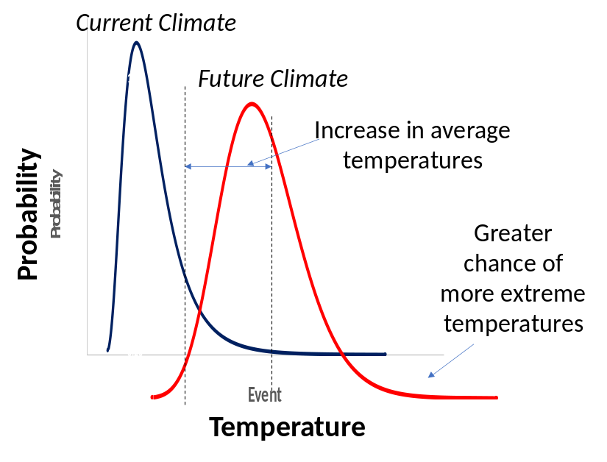
Our limited understanding of how the factors affecting global warming will inter-act with each other in the future means there is a high degree of uncertainty about the potential impacts and consequences of global warming. In other words, we do not have adequate knowledge or experience of what might happen to assign probabilities to possible outcomes or to define their potential impacts as temperatures increase further.
Even for the current climate position there is a likely time-delay between the effect of carbon dioxide that has already accumulated in the atmosphere and the consequences of this that will unfold. There is also a time delay between the consequences unfolding and the scientific measurement and understanding of them.
As one example, a warming of the North Atlantic, increased precipitation and melting sea ice could potentially irreversibly slow down or stop the Atlantic Meridional Overturning Circulation (AMOC). This is more colloquially known as 'Gulf Stream’, the surface current that brings warm water from the Gulf of Mexico to Northern Europe. As the warm water reaches the North Atlantic it cools and its salinity increases. This causes the seawater to sink towards the ocean floor where it circulates southwards continuing the cycle. If this current ceases it would result in much colder temperatures in Northern Europe, potentially more than 6 degrees on average, bringing very significant consequences for environmental change and food production.
Multiplying the uncertainty around climate change impacts are feedback loops where the consequences of rising temperatures are self-reinforcing with possible tipping points leading to a rapid acceleration of change and magnified impact of change.
These feedback loops and tipping points include:
Ice sheet collapse raising sea levels dramatically – The Antarctica and Greenland Ice Sheets are well over a mile thick on average. It could take centuries, if at all, for these to melt. A full melting of the Greenland Ice Sheet would raise global sea levels by 7.4m. Melting of the West Antarctic Ice Sheet, which is thought to be most vulnerable, and the Antarctic Peninsula would raise sea levels by 6m. Melting of the East Antarctic Ice Sheet would raise sea levels by 52m. It is not implausible that a succession of warm years in a vulnerable region combines with changing ocean currents to undermine some glaciers resulting in an irreversible collapse that could, in turn, have a cascading effect on the remaining ice. A 5-meter sea level rise that might result could leave much of New York underwater without very costly flood defences.
Large-scale Permafrost thaw in the tundra of Siberia and Canada releasing large quantities of methane – There is already evidence of this thawing with villages that were once on solid foundations now being forced to relocate. As temperatures rise and the ground thaws, trapped methane is released perpetuating the cycle.
Significantly reduced land and ocean carbon absorption Warmer oceans are less effective at both absorbing carbon dioxide and taking this carbon dioxide to the ocean floor. In some land regions, more carbon-dioxide in the atmosphere has stimulated photosynthesis which has led to more carbon dioxide being absorbed. However, there is also evidence that the general warming and the increased likelihood of drought in multiple successive years, can dry tropical rain forests turning them from carbon sinks to net carbon emitters. If these carbon sinks weaken this will leave more carbon dioxide in the atmosphere reinforcing global warming.
If these, or other unforeseen, events occur, the pace and impact of global warming could increase significantly with profound social and environmental consequences. Something of a parallel can be drawn with the financial market crisis in 2008 and the lack of preparedness for the Covid pandemic. These low probability / high impact ‘tail’ risks, and the risks of contagion they bring multiplying the impact, can lead to dire consequences. Unlike financial market turmoil and infection, however, there may be no going back from the melted ice-sheets or large-scale climate induced disaster and population displacement.

The Punchline
The speed at which global warming has been occurring and the unprecedented, in human history, levels of carbon dioxide in the atmosphere, should maintain the world’s attention and focus. It seems very likely that 2 degrees of global warming above pre-industrial levels will be reached in the coming decades. This will not be a uniform effect. Some regions will warm more than others and impacts will be felt much more keenly in different parts of the globe. For me, above all, it is the uncertainty surrounding the future impacts of global warming that is the key reason why we need to continue to act with urgency. In my view we should:
- Continue to research what is happening, why it is happening, what might happen and what can be done about it
- Continue to act, with urgency, to reduce greenhouse gas emissions where it is economically rational to do so. Ceasing base-load coal-fired electricity generation worldwide must be a priority. The economics of solar power in many parts of the world, and accompanying battery technology, means that renewable energy is the rational choice. In parts of the world where this is not so clear cut, a reasonable premium for clean energy should be included in the business case to help offset the increased cost of a robust electricity grid that can effectively cope with distributed renewable generation and account for the benefits of increased domestic security of supply.
- Electrification, particularly of transport, should progress at speed, although until there is a surplus of clean electricity generation to support this the benefits of doing this are much lower.
- Engineer electricity grid systems that are robust to variable renewable generation making use of battery storage and effective demand management through smart metering to better match electricity demand and supply.
- Continue to foster innovation that can reduce the cost of clean power, further develop electrification and reduce the impacts of global warming.

UK Energy Policy and Climate Change
The UK has cut carbon dioxide emissions significantly from the 1990 bench-mark, by which global progress is being measured, but how we got to this position was not primarily driven by climate change ambitions:
- The UK cut coal-fired power generation first for a range of reasons - of which carbon dioxide emissions was somewhat down the list - this conveniently took place since 1990.
- Energy intensive industry, and industry generally, has declined in the UK, some of this self-inflicted, with these goods now sourced particularly from China. While beginning earlier this trend very much continued in the 1990s and beyond.
This has meant the use of fossil fuels in the UK for electricity supply and for industry are relatively smaller than the global average, while transport and buildings are higher.

Use of Fossil Fuels UK
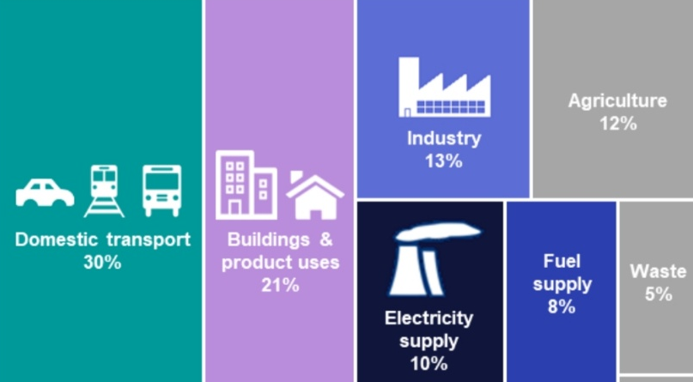
source
Why is agrigulture so high?
The current government focus in on NetZero for power generation by 2030 which will mean a switch from gas to renewewables. Gas has half the carbon dioxide emissions of coal for every MWh of electricity production and the cost of gas-fired generation at around £50/MWh is significantly cheaper than renewable energy where current strike prices for new offshore wind are around £90/MWh and nuclear is around £100/MWh. Solar is more competitive with gas but in the UK it is much less effective when it is most needed in the cold, dark winter periods and increasingly often comes at the cost of affecting rural housing and the loss of agricultural land.
Gas costs rose enormously for households as a consequence of the Russian invasion of Ukraine. This could have been largely avoided, and such shocks avoided in the future if rolling multi-year contracts that would fix prices for power generation, for industry and for consumers were put in place.
This would not necessarily resolve the security of supply issues if there was an event that significantly constrained the physical availability of gas but with LNG well established this risk is much reduced. Reversing the non-sensical action of the current government in stopping further exploitation of the residual North Sea production could further mitigate this risk.
Personal Action
What we can do individually can have a significant effect on carbon emissions – if enough of us do it. Key measures include home insulation, solar power installation, fewer car and plane journeys, not idling cars, eating less meat, being mindful of packaging, reducing fast fashion. Personal self-interest can, though, be hard to overcome. Most of us will only do so much for the common good. It is easier for middle class for whom it may be a modest inconvenience/expense and who may have the money to make an up-front investment, but this isn’t the case for people that are surviving day-to-day.

Science and policy to implement change are different things. Doing these things has to be politically acceptable. No one wants to be forced to do things. Damage to the economy is real. Stopping North Sea oil drilling seems an act of self harm to the British economy. The oil will simply come from petro-states where the economic incentive it to get it out of the ground as fast as possible while maintaining good prices. Damaging the industry behind it reduces the potential for export of UK services

Policy Objective

- More affordable domestic electricity prices
- Internationally competitive industrial electricity prices that are predictable enough to support investment decisions
- Reduce carbon dioxide emissions where it is rational to do so ensuring price signals for investment choices by domestic, commercial and industrial users that reflect the real social, economic and climate costs of fossil fuel power
- Improve energy security with less reliance on imports
- A robust energy grid that will not fall-over
- Electrification in preference to use of fossil fuels to spread the electricity infrastructure costs across a greater demand
- Capitalise on the UK skills, particularly built up in the North Sea oil industry and in the development of offshore wind power to sell services.

Removing Standing Charges from electricity bills is a simple administrative change which helps low‑income households with low consumption and, modestly, reinforces electrification incentives

Adoption of domestic Heat Pumps and Electric Vehicles is a key next step in transition away from fossil fuel use in the UK. As things stand this will be difficult to achieve, (infrastructure and supply chain issues aside), unless households feel they have choice and can make economically rational decisions in their own interests.

Car tariffs
Proposed Policy Change
 | Policy Step | Explanation
1. | Nationalise (domestic) electricity and gas retail supply companies into a single organisation | - I define electricity and gas retail supply as the activities of electricity/gas purchasing from producers, billing of customers, metering and customer service.  - These elements are natural monopolies with relatively low value-add. There is a standardised product (electrons/gas molecules), fairly uniform bills and very similar customer service issues. A lot of money is wasted in the costs of duplicate billing systems, the costs of managing electricity price risk and in advertising  - Existing suppliers could be fairly and simply recompensed for the nationalisation based on a simple formula (e.g. given margin/kWh x typical annual energy usage x assumed customer retention in years = £200/customer as an illustrative value. This margin/kWh would continue to be charged by the nationalised organisation meaning that the existing suppliers could be paid via an ‘earnout deferral’ type mechanism at no funding cost to government.
2 | Provide a strong price signal to individual households by increasing the unit price of gas, potentially by circa 30%) and, at an individual household bill level, reduce the unit price of that households electricity by exactly the equivalent amount. | - The increase in the unit price of gas is essentially a proxy for the climate externalities.  - Individual households are financially no better or worse off  - An equivalent mechanism could also potentially apply to Housing Association/private landlords in the case of rental properties  - An equivalent could be applied to those households that heat their homes with oil-fired heating by increasing the rate of VAT on domestic oil and providing the equivalent credit on their electricity bills
3 | In the case of heat pumps, make available a repayable grant to cover part or all of the installation cost of conversion where approved kit / installers are used. | - The grant is ‘secured’ against the individual households future energy bill and provide by government meaning that the financing cost is as low as it can be  - In the event of the home owners moving the heat pump repayment would transfer in the new owners  - A similar repayable grant mechanism could also potentially be applied for electric vehicles
4. | As a complementary measure eliminate the standing charge on domestic energy bills and remove, where possible, levies from electricity bills to strengthen the price signal | - This will tend to benefit poorer households  - Unit costs can still vary to reflect differing regional distribution costs

Outcomes
- With clear communication, fostered by the national organisation carrying out the billing, households will be more inclined to make a positive choice about whether and when to install a heat pump / EV charging
- Significant contributes to achieving the climate/energy policy objectives
- Does not compel consumers to make changes
- In theory, no net cost to government or individual households

Additional benefits of a nationalised energy retail organisation
- Price signals more easily communicated via a national electricity retail supplier in conversation with the grid operator. This would be particularly beneficial in the case of using electric vehicle charging to help balance overall grid supply/demand, potentially also at a more localised level to relieve local distribution network constraints
- Better enable the benefits of the smart metering to be realised
- Financial savings from duplicate processes in multiple electricity retail supply
- If also applied to business customers this would more readily enable them to contract energy supply prices for longer / rolling periods with the national energy retail organisation to avoid international energy price shocks.
- Easier to communicate and apply social tariffs
- More straightforward application of feed-in tariffs and price signals for domestic solar/battery installations
- Stops electricity retail supply companies going bust when they make energy price risk management / other mistakes and the loading of this cost on other energy consumers

why is electricity much more expensive than Europe
People that can build renewables now are making super-normal profits for as long as the price of gas drives the price of electricity.
Use the money to subsidise electricity costs of manufacturers

Look at annual report from climate change committee and its risk report

Exercise the precautionary principle - there as been a decline in teh worst
Why are coal plants being built when cheaper alternatives - projections for worldwide coal generation. Twice as much CO2 from coal as from gas
If we are going to spend – make money count – grow aid again by investment in solar where it is sunny
If we are going to subsidise for environmental reasons Foster solar and battery where it can make most impact - Africa - global equity - the industrialised countries got rich on the back of fossil fuels - poor reaping the consequences
Strengthening and interconnecting electricity grids to maximise renewable power that can be connected and produced
Research in CCS and geo engineering
Tax environmentally wasteful consumerism 0 swimming pools? Air con, oil, Road Tax on inefficient cars,
Revisit government climate change plans - Policy to achieve net zero by 2050 is a signal to other countries and the carbon budgets it contains to progressively reduce net carbon emissions compared to 1990 levels are the key reference for assessing international action via IGPCC and COP.
assuming more sustainable aviation fuel seems over ambitious, cheaper industrial electricity prices by switching from gas?)
cost of achieving the final stages to reach net zero by 2050 are prohibitive requiring expensive subsidy - better to spend that money in the developing world where get a much bigger 'bang for your buck'

Solutions
- There has been a significant increase in solar and wind, however this has barely kept pace with increased demand. Price of solar has fallen dramatically globally, on the back of Chinese manufacturing cost savings has made has made solar power competitive with fossil fuels. However in the UK the relatively poor load factor of solar and the installation cost (land / grid connection) remains costly, some of this advance may come with environmental damage through mining the ores needed, poor labour conditions and cheap coal-fired power to produce, It should be noted there are major subsides on both sides – for fossil fuels the cost of carbon and for renewables the cost of intermittency
- Battery storage to make best use of renewable energy- again price is falling
- Geothermal
- Hydropower – mature technology already quite well utilised although opportunities remain
- Nuclear SMRs providing baseload power that is not
- Planting trees - but not a permanent solution
- Biomass storage to sequester carbon - while avoiding competing with food production and changing land use in a way that reduces existing absorbtion of carbon. Biochar
- Carbon Capture and storage - only known way to permanently remove carbon dioxide from atmosphere ultimately may be needed to suck carbon out of teh atmosphere, but demands huge energy to extract when the concentration is measured in only the hundreds of parts per million
- Nuclear fission
- Geo-engineering - Significant potential for conflict

Solar strike price £50/MWh Offshore Wind £91/MWh
Moved renewables cost from bills to general taxation

